

USER INTERFACE DESIGN DOCUMENT
Version: 1.3
HR DATA DASHBOARD PROJECT
Course: System Integration Practices
Semester: 2 – 2024-2025

Mentor: MSc.Nguyen Dang Quang Huy
Team Member:
Lan, Mai Hoang
Hiep, Le Hoa
Khoa, Pham Anh
Ky, Ngo Hong
Thanh, Truong Cong

Da Nang, 16/05/2025

PROJECT INFORMATION
Project Acronym | HRD
Project Title | HR DATA DASHBOARD PROJECT
Start Date | 16 – March –2025 | End Date | 16 – May –2025
Lead Institution | International School, Duy Tan University
Role | Name | Email |  | Phone
Project Mentor | Nguyen Dang Quang Huy | huyndq@duytan.edu.vn |  | 0935525354
 | Mai Hoang Lan | maihoanglan30@gmail.com |  | 0869090860
 | Le Hoa Hiep | lehoahiepk98@gmail.com |  | 0867797246
 | Pham Anh Khoa | phamanhkhoa027@gmail.com |  | 0763538820
 | Ngo Hong Ky | kingohong@gmail.com |  | 0334595134
 | Truong Cong Thanh | congthanhire@gmail.com |  | 0367163476

DOCUMENT NAME
Document Title | User Interface Design Document
Reporting Period | 16 – March - 2025
Author(s) | Le Hoa Hiep, Pham Anh Khoa, Truong Cong Thanh
Role | Developer
Date | 16/05/2025 | Filename | User-Interface-Design.docx

SIGNATURE
Document Approvals: The following signatures are required for approval of this document.
Mentor | Huy, Nguyen Dang Quang | Signature:
 |  | Date:
Project Manager | Lan, Mai Hoang | Signature:
 |  | Date:
Team member(s) | Hiep, Le Hoa | Signature:
 |  | Date:
 | Khoa, Pham Anh | Signature:
 |  | Date:
 | Ky, Ngo Hong | Signature:
 |  | Date:
 | Thanh, Truong Cong | Signature:
 |  | Date:

REVISION HISTORY
Version | Date | Description
1.0 | 22/03/2025 | Create User Interface Design Document
1.1 | 22/03/2025 | Update Payroll & Attendance, Month salary history
1.2 | 23/03/2025 | Update UI Employee Management
1.3 | 24/03/2025 | Update UI Department & Position Management

TABLE OF CONTENTS

1. Introduction 7
1.1. Purpose of Document 7
1.2. Scope of Document 7
1.3. Document Overview 7
2. List of User Interface for Sprint 8
3. Describe User Interface 11
3.1. UI-01: Login 11
3.2. UI-02: Dashboard 13
3.3. UI-03: Sidebar 15
3.4. UI-04: Payroll Management 17
3.5. UI-05: Salary history 19
3.6. UI-06: Update payroll details 21
3.7. UI-7: Employee Management List 23
3.8. UI-8: Applicant Management List 25
3.9. UI-9: Update Applicant Information 27
3.10. UI-10: Add New Applicant 29
3.11. UI-11: Update Employee Information 31
3.12. UI-12: Department Management 33
3.13. UI-13: Position Management 35
3.14. UI-14: Update Department Information 37
3.15. UI-15: Update Position Information 38
3.16. UI-16: Add New Department 39
3.17. UI-17: Add New Position 41

TABLES

FIGURES

Introduction

1. Introduction

1.1 Purpose
Mục đích:
Trình bày mục tiêu chính của tài liệu — giải thích lý do cần xây dựng tài liệu này

1.2 Scope
Mục đích:
Xác định phạm vi, giới hạn nội dung của tài liệu.

1.3 Definitions, Acronyms, and Abbreviations
Mục đích:
Liệt kê các thuật ngữ, từ viết tắt được sử dụng trong tài liệu.
Hướng dẫn sinh viên viết:
- Tạo bảng như sau:
Acronym/Term | Definition
HUMAN | Human Resource Management Database (SQL Server)
PAYROLL | Payroll Management Database (MySQL)
PK | Primary Key
FK | Foreign Key
ERD | Entity Relationship Diagram

1.4 References
Mục đích:
Liệt kê tài liệu và nguồn tham khảo.
Hướng dẫn sinh viên viết:
- Case Study 1 – Problem Statements
- Software Requirement Specification (SRS) Document
- IEEE Std 1016-2009 – Standard for Software Design Descriptions
- CMU-CS445 Course Material, Duy Tan University (2025)

List of User Interface
Roles | User Interface ID | UI Name | Description
User | UI-01 | Login | This page allows authorized users to securely access the system with pre-assigned credentials. No user registration is available.
User | UI-02 | Dashboard | Provides an overview of key business metrics, including human resource reports, salary reports, and dividend reports. Includes visual representations such as summary cards, bar charts, and a pie chart for traffic sources.
User | UI-17 | Add New Position | Allows the admin to add a new position with salary range and job title.
Table 1: List of User Interface
- Describe User Interface

UI-01: Login
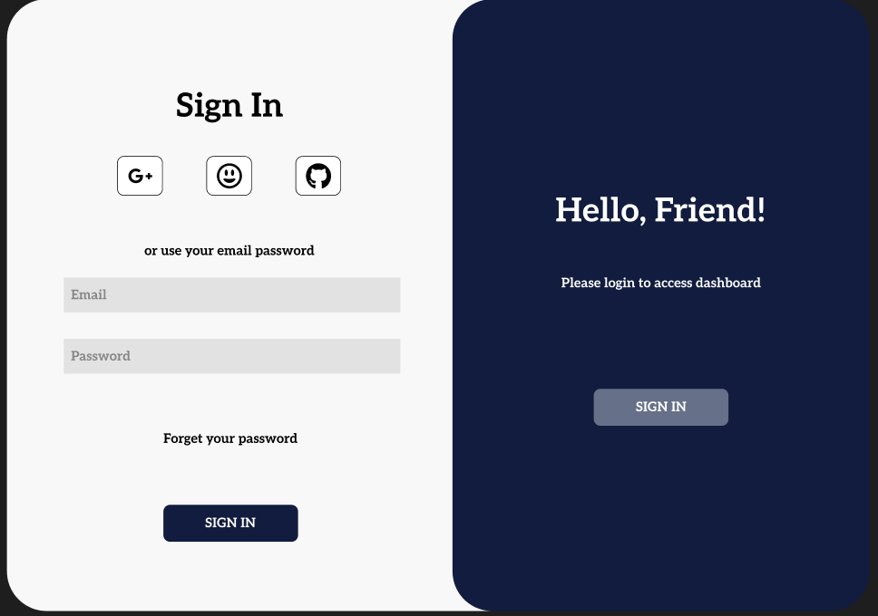
Figure 1: Login

ID | Condition | Control Type | Target
1 | View | Text | Sign In (title)
2 | Press | Icon Button | Sign in with Google
3 | Press | Icon Button | Sign in with custom user
4 | Press | Icon Button | Sign in with GitHub
5 | View | Text | Show all valid data
6 | Press | Input | Enter email
7 | Press | Input | Enter password
8 | Press | Text Link | Forget your password
9 | Press | Button | Sign In (main action button)
10 | View | Input | Hello, Friend!
11 | View | Input | Please login to access dashboard
12 | Press | Button (disabled) | Sign In (right panel button)
Table 2: Home Page (Website)

